Imagined Speech Prediction From EEG Waves
17.10.2020
─
Project Supervisor
Dr. Humera Tariq

Group Members
Syed Osama Hussain - B16101170
Mubashir Ali - B16101075
Muhammad Salman - B16101110
Bilal Raees - B16101154

Motivation
People suffering from mental illnesses are often unable to express themselves fully due to lack of words. In-addition people with no ability to communicate are more prone to depression and anxiety, almost all of which goes unnoticed which ultimately leads to shorter life expectancy. We aim to develop a system through which we can decode imagined words and predict future words.

Overview
- Significance:
This project carries great significance, if implemented completely. It can not only be used for people who can’t communicate in any way but to aid psychiatrists in treating patients. In-addition, it can also be used by researchers to understand thinking patterns and in general, working of our brain. Thus, this project has great prospects in Health Care and Research.

- Description:
The project will use EEG (Electroencephalogram) brain waves to acquire data from the brain which will then be passed through a network of Deep Neural Networks. A user can simply plug-in their EEG headset (64 channels) and decode their imagined words and also predict future words. The result can be then obtained in a file which can be studied further by downloading it.

- Background:
EEG measures changes in electric potentials caused by a large number of electric dipoles formed during neural excitations. Different waveforms are obtained when measured through an EEG headset or device which can be used to provide signals to sensors as well as extract features according to the actions performed by the brain. In the past different techniques have been used including neural networks to decode features from EEG data. We propose a network of DNNs which will extract words thought in a person’s mind and predict the next thought word using a Recurrent Neural Network. The aim is to design such a system which can be used by hospitals, clinics and research institutes using their own EEG equipment. This can be achieved by providing a web based SaaS (Software as a service). The EEG data obtained must be passed through a standardized procedure to maintain consistency. This system can also be extended by using a distributed and secured approach like BlockChain and can also include voice feedback for predicted thoughts but that is for future work at the moment.

Methodology
The initial approach has been adopted from a recently published research paper [1]. Since the purpose of the publication is to demonstrate a method rather than to present a practical implementation, the development of such a system for practical applications is a challenging task in itself. Other major hurdles are acquiring equipment and extending the training dataset. The current dataset is available for only five words and three vowels [2].
We will follow an incremental strategy for the development of this project. The project can be divided into phases which can make the task modular. We can add more functionality when a preceding phase has been successfully developed.
- Design:
The first phase, as it should be, is the design phase. Most of the core design comes from the research paper. However, the high level design, extension of the core design and integration with the application is needed. The extension of the model is subject to change according to the results achieved.
- Data Preprocessing:
Since we are following a predefined initial model, it is important to preprocess data according to the format, it has been tried and tested on. This mainly involves computing the cross covariance matrix of the channel data obtained from the EEG headset and the relevant format accepted by the first model in the network.
- Initial Model And Hardware:
  - Hardware: We plan to develop the initial hardware for the EEG headset. It will consist of a circuit and a number of channels (attachable electrodes on the head). We will remain modest in the number of channels (16) and will increase them to the number of channels used in [1] and [2] i.e 64 once we know that the circuit can handle this much load.

  - Model: The initial model will only aim to decode the imagined words and not to predict future words. Instead of a single Neural Network, it is proposed to develop a network of more than one DNN. The features extracted from one Neural Network will be passed onto the next model, hence, the word hierarchical.
- Model Extension and App:
Once the network of models is working as in [1] and deployed, we can extend it to predict future thoughts. Since the initial model will be deployed and the hardware will be able to generate some readings, the web app developer can start working on the application and make it ready for use.
- Data Set Extension:
Once the minimum requirement of the project has been achieved and can work on the five words, we can extend the data set on the same format as in [2]. We may need a more efficient EEG headset for this task. We aim to add 30-40 words which are commonly used in speech to demonstrate our project. Once everything is working and we have the processing power and storage space more words can be added to the dataset.
Note that since we’ll follow an incremental approach and some phases are independent of the others, they can be tested individually and integration testing can be done once they are merged.

Architecture Specifications
We divide the architecture of the project into three major categories depending on the expertise and domain of each category. Following is the complete architecture for the project:
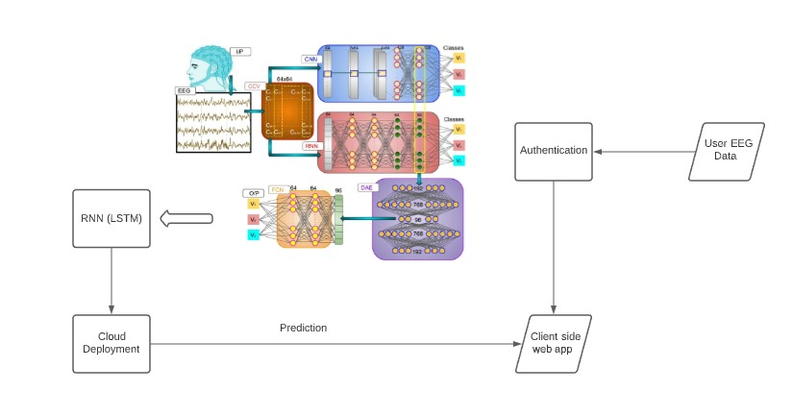

The model can either be deployed independently or bundled with the back end, depending on the tech stack used for the web application. The Hardware is required for testing the working model and extending the data set.

Hardware:
The EEG headset can be divided into two parts, i.e the circuit and the electrodes. The circuit will be made by us following the design presented in [3]. The electrodes are placed on the head and attached to the circuit to record the waves. The circuit diagram is given below:
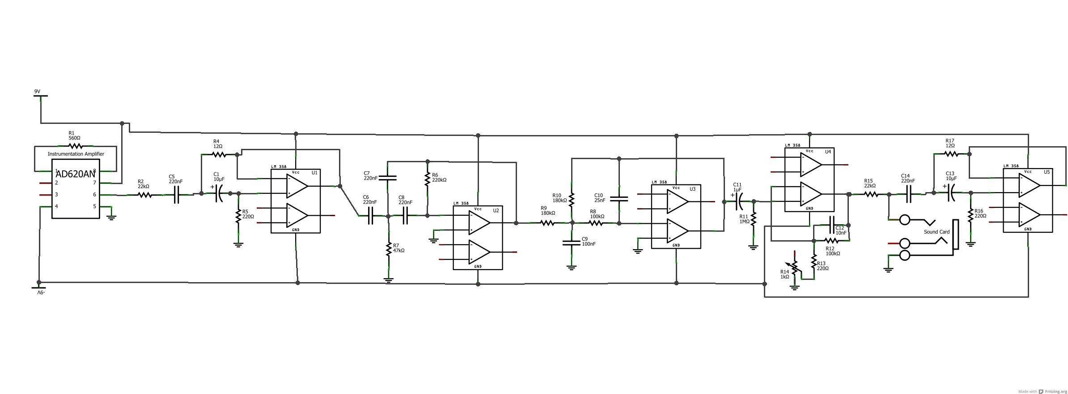
The first step is to use an instrument amplifier, used to amplify very low-level signals, rejecting noise and interference signals. We will use AD620AN as our instrument amplifier. The second step will be to remove the noise in our system, due to power line interference. Even if we use batteries to power our circuit, our circuit will still experience this noise. For this reason, we will create a filter that will assure that the noise is centred at 60Hz. The third step will be, as we are measuring data across the skin, our final data will also contain voltage from our galvanic skin response across our head. This will obscure the brain data we want. This filter is a 2-pole HPF, which will cut-off the frequency up to 7hz. Next up, we want to filter out data above the frequencies we are interested in. More specifically, as beta wave information stops out at 30Hz, we want to get rid of anything above that. The next step is to create a quick HPF of cutoff frequency 1Hz, just for some extra attenuation of unwanted noise. On the other end, the resistor and capacitor in parallel provide some extra filtering of high frequencies. Even with all the previous filtering stages, the data will still at this point contain a good amount of 60 Hz noise. To fix this, we will process it through another notch filter centered at 60 Hz, identical to the previous one. The final data will still have a small amount of noise, but that can be ignored through software once the data is loaded into the computer, using a 3.5mm male-to-male cable.

Prediction Model:
We will use Keras API available for python to develop the model. As seen in the figure above the EEG data will not be directly fed to the network but we will compute channel cross-covariance, resulting in matrices. Next a mixed neural network architecture composed of three supervised and single unsupervised learning will be used. First the covariance matrix will be passed to a CNN and a RNN. A RNN is needed to explore the hidden temporal features of the electrodes. Both of these networks will be trained individually and the fifth layers of these networks, containing feature vectors, will be concatenated to form joint spatio-temporal encodings of covariance matrix. The second level of hierarchy will encompass unsupervised training of deep autoencoders. Then, the discrete latent vector representation of the deep autoencoder will be fed into a two-layered fully connected network.
The first part has been adopted from [1] and is enough for predicting the imagined speech. In the next step we will aim to extend this functionality by using a RNN with LSTM layers to predict what word will a person imagine, next. The principle is the same as that of predictive text used in Search Engines.

Web Application:
The web application will act as an integration point for the project. Once the model is trained and running it can be deployed either with the web app or separately. The web application will be divided into the back end and front end. The front end will be responsible for the visualization of the app and collection of input sent through the EEG headset. The front end will communicate with the back end via an API. The back end will format the EEG signals into the format accepted by the model and return the prediction, to be managed by the front end. We will also implement user authentication for security.
We have two options for the tech stack. We can use MERN stack or Django with React. This depends on some factors such as, the prediction time and size of the model, API format etc and will be decided once the model is completed.

Requirements

Hardware
The initial hardware requires some supplies, such as micro-chips, capacitors, resistors and connectors. We would also need electrodes to connect to the scalp and draw readings. Detail of the parts is given below:
- Chips: 1x Instrumentation Amplifier - AD620N, 2x Quad Op-Amp - TL084CN.

Capacitors: 1x 10 nF (ceramic), 1x 20 nF (ceramic), 1x 100 nF ( tantalum), 5x 220nF (tantalum), 1x 1uF (electrolytic), 2x 10uF (electrolytic)

- Resistors: 1x 1kΩ Potentiometer, 2x 12Ω, 1x 220Ω, 1x 560Ω, 2x 22kΩ, 1x 47kΩ, 2x 100kΩ, 2x 180kΩ, 1x 220kΩ, 2x 270kΩ, 1x 1MΩ.

- Connectors: A breadboard, Wires, 3.5mm audio cable, 2x 9V batteries for power.

- Other Supplies: Electrodes, Ambu Neuroline Cups, Electrode Gel.

Although we are making our own EEG headset, it may be possible to draw some readings from it but it's unlikely that it will be reliable enough to add more trainable data to the data set. We may require a better EEG headset from a reliable source. We could either print the design using a 3D printer since it's Open Source [4] or we may need to buy it if a 3D printer is not available.

ML Model:
We will require some processing power (GPU) that can be obtained from Google Colab which offers upto 11.4 GB of GPU support and 34 GB of memory which can be enough for a few GB of training data (5.3 GB) in our case. However, we may need more resources if we extend the data set from 5 words to at least 30-40 words. These resources can be acquired from GCP AI Platform [5].

Deployments:
For deployment of the web application, we can use GCP App Engine. The free tier will be enough, since it will have basic authentication, collection of data and API calls to the ML model for prediction. For the deployment of our ML model we will again need to use the GCP AI Platform which allows serverless deployment and rest API for the prediction.

Work Distribution:

Task | Members
ML Model | Osama and Mubashir
EEG Hardware | Salman
Web App | Bilal
Integration & Testing | All members

Project Milestones:

Task | Sub Task | Days
ML Model | Data Preprocessing | 19 Oct - 1 Nov
EEG Hardware | Circuit Designing | 19 Oct - 19 Nov
Web App | User Authentication | 19 Oct - 25 Oct
Web App | Database and Routes | 26 Oct - 8 Nov
ML Model | Initial Model | 2 Nov - 1 Dec
EEG Hardware | Electrode Integration | 20 Nov - 27 Nov
EEG Hardware | Microcontroller Integration | 28 Nov - 5 Dec
Web App | Front end | 9 Nov - 23 Nov
Web App | Front end integration | 24 Nov - 30 Nov
Integration | First Working Demo | 2 Dec - 6 Dec
ML Model | Model Extension | 7 Dec - 21 Dec
ML Model | Data Set Extension | 22 Dec - Till Submission

Note that after the first integration, we will simply replace the deployment of the model after every iteration of the model and data set extension. The dates can also vary depending upon the availability of resources and hurdles faced.

References:
- https://www.researchgate.net/publication/335177564_Hierarchical_Deep_Feature_Learning_for_Decoding_Imagined_Speech_from_EEG

- https://www.researchgate.net/publication/318712007_Inferring_imagined_speech_using_EEG_signals_a_new_approach_using_Riemannian_Manifold_features

- https://www.instructables.com/DIY-EEG-and-ECG-Circuit/

- https://github.com/OpenBCI/Ultracortex/tree/master/Mark_IV

- https://cloud.google.com/ai-platform

